**NOAA Ship THOMAS JEFFERSON Procedure Document**

Procedure:

**Creating a Line File in Hypack**

Creation Date:

**2019-12-16**

Revision Date:

**NA**

Procedure Number:

**TBD**

Approved:

**TBD**

# 1. Overview and Scope

This is an SOP on how to create a line file in Hypack. There are many different ways to create a line file and there are many different applications that can be used to make a line file. This tends to be the fastest and easiest.

To find out how to calculate line spacing please refer to the Line Spacing SOP on the K drive.

# 2. Procedure Inputs and Outputs

Inputs:

N/A

Outputs:

.lnw \

# 3. Procedure

1. First open Hypack. You’ll need to have a Hypack key (USB with a license on it) to make a line plan.

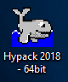

1. With Hypack open, navigate to the upper left hand corner and click on the editor drop down (pencil and paper icon).

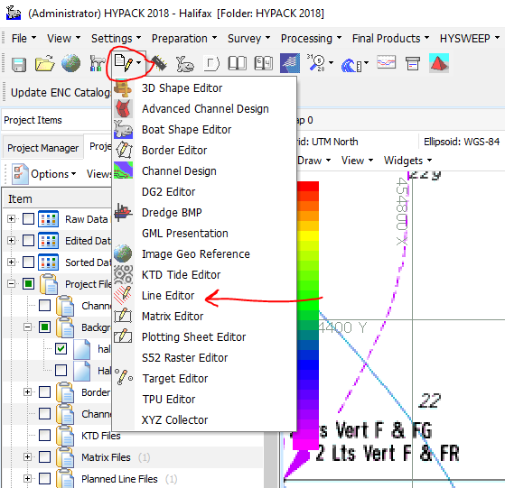

1. Go to the Line Editor option and click it. A dialog box should open.

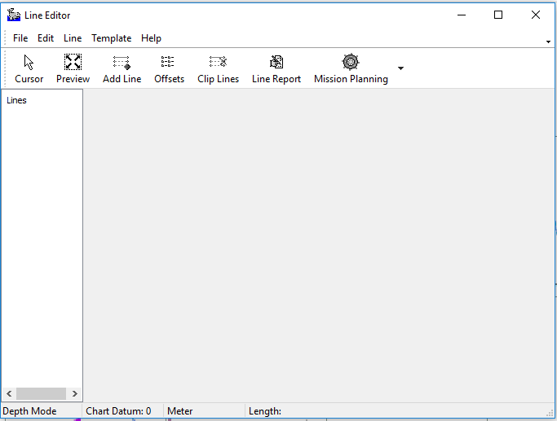

1. To start your line plan, your best option is to click the Cursor option. This will automatically close the line editor window; then, anywhere you click on the map area will drop the first point of a line.

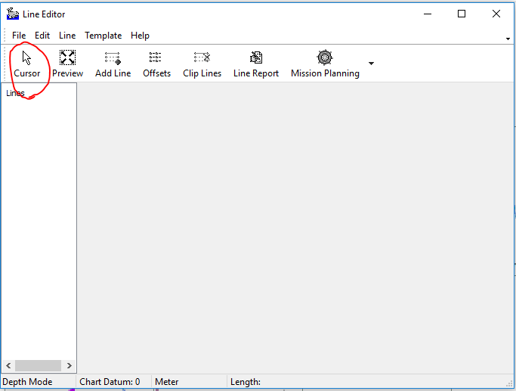

1. Go ahead and drop two points so that your line is down the center(ish) of whatever you are making a line plan over.

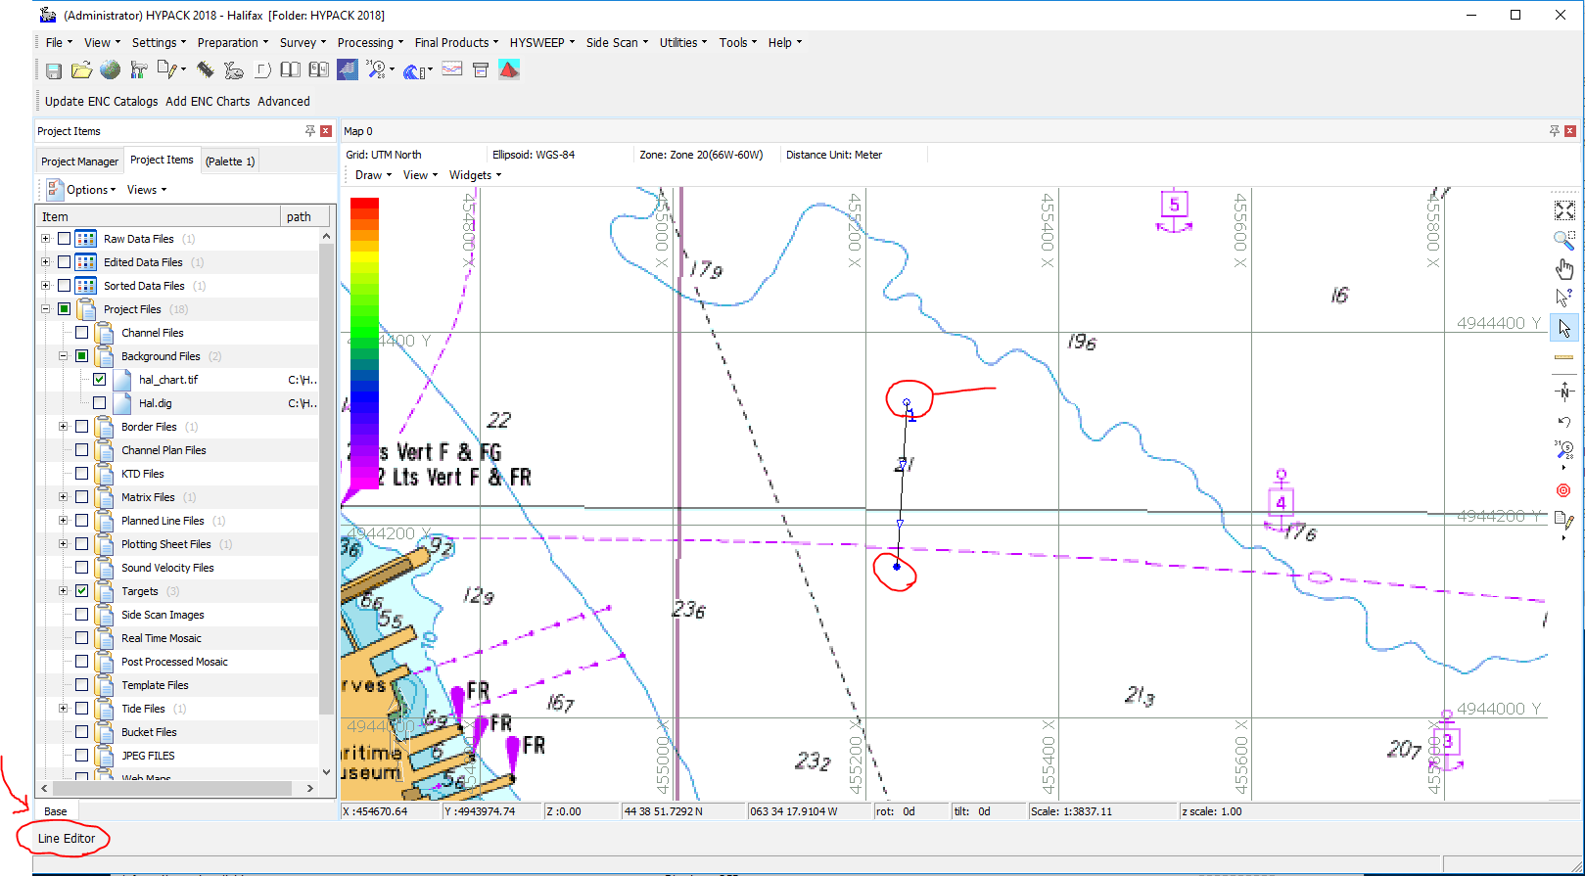

1. After you have your first line, reopen Line Editor by navigating to the bottom left of the screen and clicking the Line Editor button (see image above).
2. You should see a line and its coordinates in the Line Editor window. Click the Offsets button in the upper center of the window.

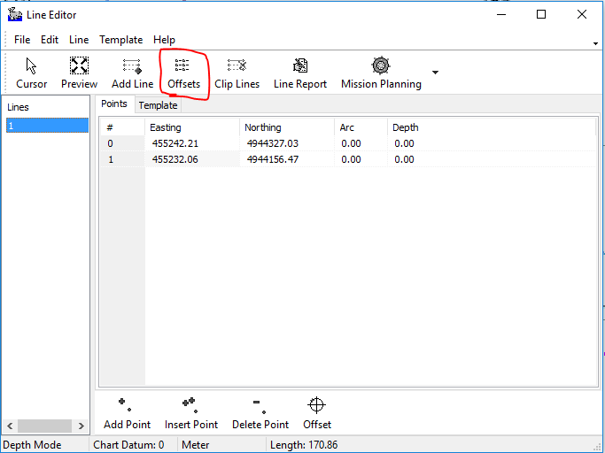

1. This should prompt another window to open. This is where we will be estimating a little bit. You will be guessing how many lines will fill your polygon/make a line plan of good enough coverage. Fill in how many lines to draw to the left and to the right of the center line you created. The distance between the lines needs to be calculated separately. If help is needed figuring out the line spacing (distance) there is an SOP in the K drive as well as a few spreadsheets that calculate line spacing.

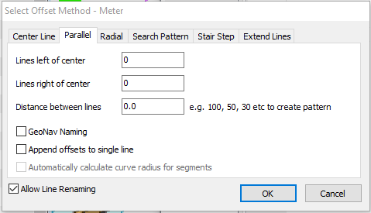

1. Here we are using 6 lines to the left and 6 to the right with a spacing of 20m in between the lines (I just used random numbers for this).

**Don’t be alarmed if your centerline isn’t labeled as #1 anymore. It automatically renumbers them, however, lines can be renamed (renumbered) utilizing the renumber lines tool in the Line drop down**

1. This is what your lines should now look like. If you have created a good enough line plan, then you are set. Just hit File > Save as in Line Editor and save this .lnw in your working folder in G:\OPR-XXXX-TJ-XX\HXXXXX_WORKING\01. Planning\04. Line_and_Polygon_Files\01. Lines. As for naming conventions, it is best to be as descriptive as possible (SHEETNAME_LINESPACING(m)_VESSEL).

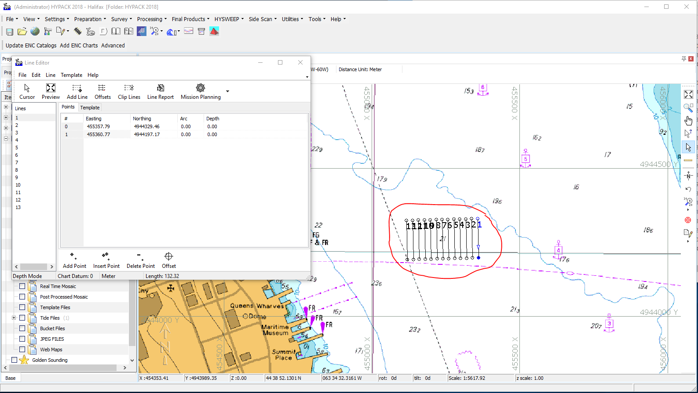

1. There are a couple of other things that you can do with this feature in Hypack. You can extend your lines by going back into the offset window, clicking on the ‘Extend Lines’ tab, and extending them by a desired value. You can also clip your lines to a border file by using the Clip Lines option in the Line Editor window. This is extremely useful when making a line plan to fill in a polygon/sheet limits.
   * 1. 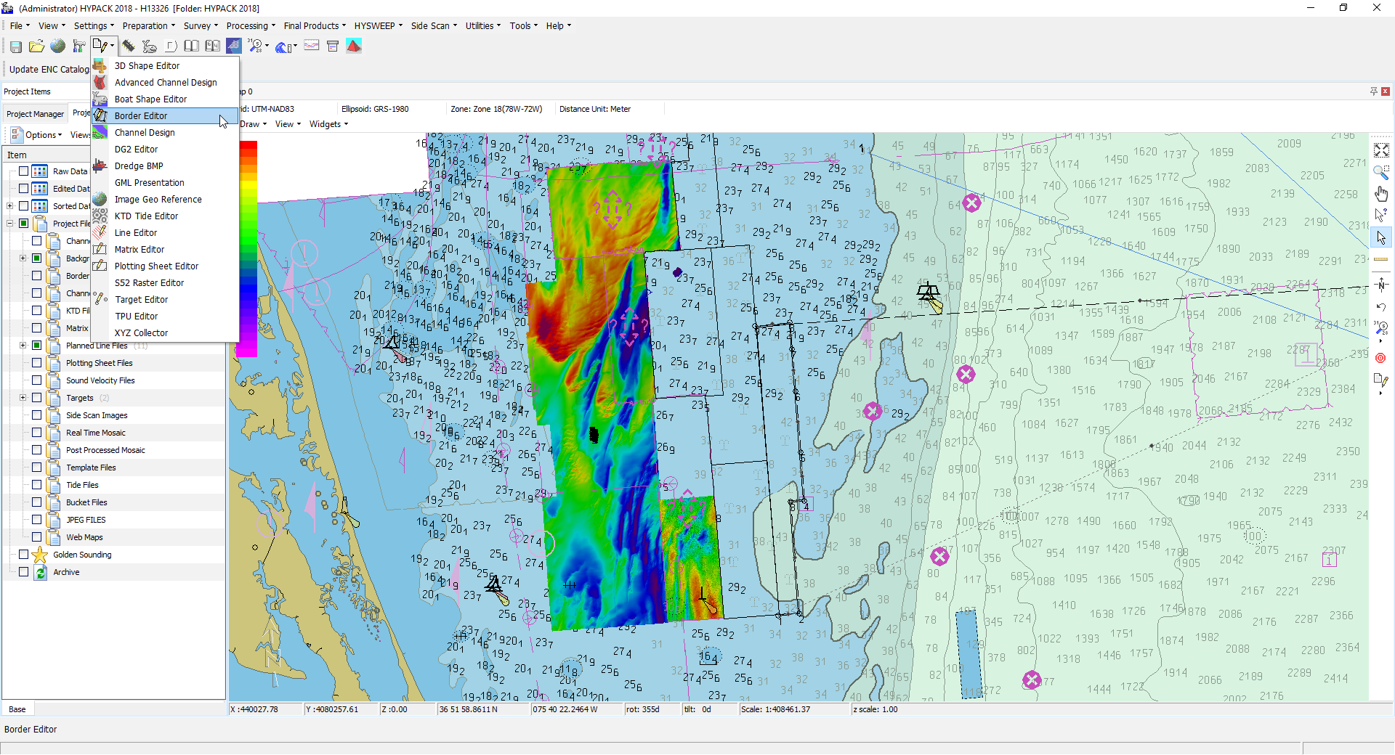To clip lines to a border, you first must use the Border Editor tool, which can be found in the editors dropdown menu (pencil and paper icon).
     2. 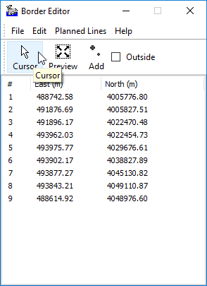When the Border Editor dialog box opens, select the Cursor option.
     3. Next, you need to create your border by dropping points around the area you want to make the lines over. Usually I’ll use this tool when starting a survey. (ArcMap gives me a headache so I prefer to create my line plans in Hypack.) I’ll load in the shapefile for the assigned survey sheet and then drop points around the sheet limits (adding a bit of gap to account for the buffer required).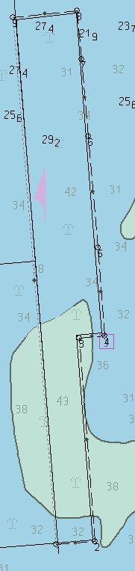
     4. Save your border and exit out of Border Editor.
     5. 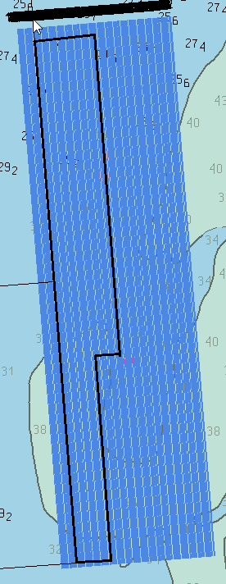Next, open Line Editor and select the Cursor mode and make a single line down the longest edge of your assigned sheet. Using the Offsets tool (described in steps 7-9), completely cover the assigned sheet with lines set to the appropriate line spacing. (It doesn’t matter if you make too many lines. They’ll go away once you clip them to the border.)
     6. Finally, in the Line Editor dialog box, select the Clip Lines option and load in the border file that you created.

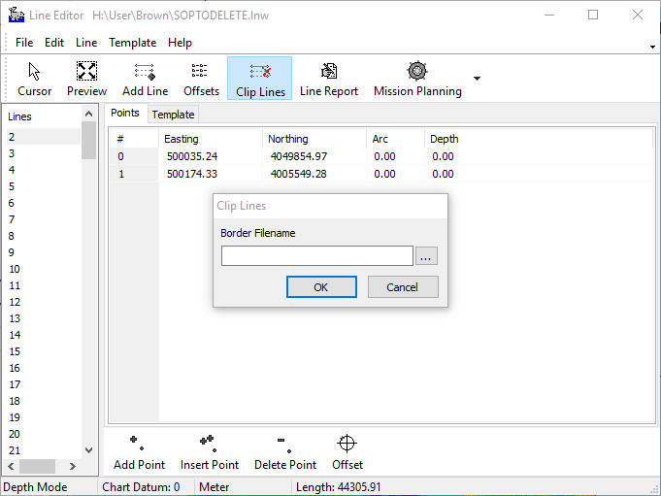

* + 1. This will remove all the unnecessary lines and clip all of the appropriate lines to the correct buffer required for your assigned sheet. (Remember that if this seems too difficult, there is always ArcMap to create line plans and sheet limits. A lot of people find Arc to be easier to use, but this is just a way that I have found that is a little easier for me. Hopefully it helps you.)

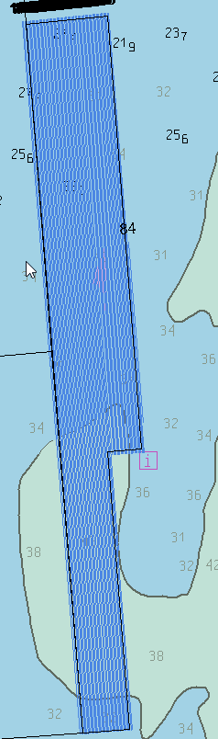

# 4. References

N/A